Irish Taekwon-Do Association
Dublin Open International 2023
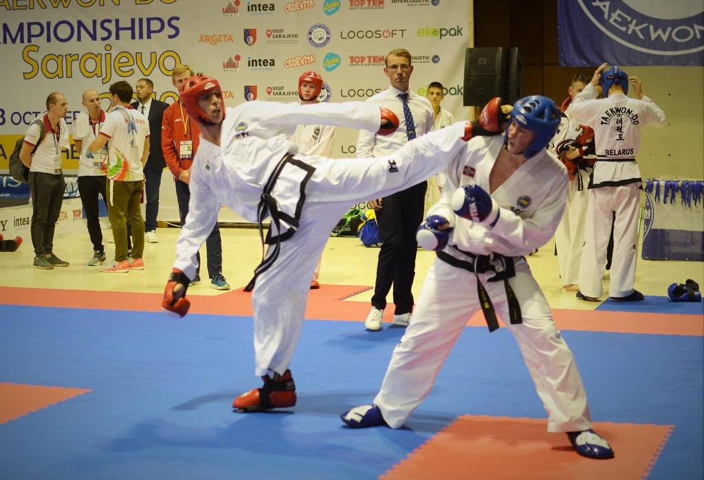

11th – 12th March 2023
Gormanston College
Date: 11th March 2022 – All black belts and Colour Belts 14+
12th March 2022 – Colour Belts 13 and Under

Location: Gormanston College

Registration: From 8:30am on both days of competition

Weigh in: Friday (TBC Please check ITA Facebook for Updates) Saturday 8:30am – 10:30am
Height Check: Sunday During Pattern competition
Umpire Meeting: 9:30am on both days
Start of competition: 10am on both days
*Sunday will be split into different start times for Under 10 and 11-13 (Please check ITA Facebook for Updates)
Entry Fee: €30 per competitor
Important Dates:
13th February 2022: Online Registration Opens
3rd March 2022: 23:59 Registration Closes
9th March 2022: Schedule Published Online
** Withdrawal of competitor before 3rd March is possible without a fee ** competitors withdrawn after this date subject to full entry fee
**PLEASE NOTE**
** Errors in sparring categories entries may be rectified on the day of the event at ** the discretion of the Tournament committee, all changes are subject to a €10 fee, this fee must be paid before the change is made
No changes/additional entries in pattern, sparring, special technique or power categories on the day of the event and any competitor entered in the wrong category will be removed
Age Categories
Saturday: Cadet Colour Belts (14-17), Under 15 Black Belt, 14-17 Black Belts, Senior (18+), Veteran (35+)
Sunday: Under 10, Colour Belts (11-13)
Categories
Patterns
Colour Belts: Optional Pattern
Black belts: Preliminary Rounds: 1 x designated patterns (Chon-Ji - Current Grade)
Semi Final & Final: 2 x designated patterns
This is for Cadet and Senior patterns only, Under 15 and Veteran Black Belt categories will be from Chon-Ji – 1st Dan Patterns
Sparring
Saturday: Weight Categories
Sunday: Height Categories all Under 10, 11-13 Yellow/Green
Height/Weight for 11-13 Yrs Blue/Red Belts*
*Note: For 11-13 years Blue/Red belts, categories are initially divided by height but may be adjusted or modified at the discretion of the tournament committee to take competitor weights into account, please also include weights on entries for these competitors
The organisers reserve the right to further divide categories if there is a large difference in weight/height across the category.
Match Times
Under 10: 1 round, 1.5 minutes
Colour belts (11 yrs+): 1 round, 2 minutes
Black belts (3 competitors Pools): 2 rounds, 1.5 minutes
4+ Competitors Black belts:

Main Draw: 2 rounds, 1.5 minutes
Finals: 2 rounds, 2 minutes Requalifying matches for 3rd place: 1 round, 2 minutes
Special Technique Blue/Red Belt 11 Yrs + M/F: Front Kick & Side Kick
Black Belt M: Front Kick, Reverse Turning Kick, Side Kick F: Front Kick, Turning Kick, Side Kick
Power Black Belt M: Knifehand Strike, Turning Kick, Reverse Turning Kick
F: Knifehand Strick, Turning Kick, Side Kick
Umpires
Saturday: 1 – 7 competitors = 1 umpire, 8 – 14 competitors = 2 umpires etc.
Sunday: 1 – 10 competitors = 1 umpire, 11 – 20 competitors = 2 umpires etc.
We need as many senior umpires as possible to ensure a high level of refereeing on all rings.

All umpires will receive free lunch and snacks on the day of the competition.
Umpires must wear: Navy pants, navy jacket, white shirt, tie, white shoes.
International teams may be excused the requirement to provide umpires
Coaches
There will be no coaching allowed during patterns.
Clubs must meet the umpire to competitor ratio on each day they to receive coaching passes
1-15 competitors = 1 coach, 2-30 competitors = 2 coaches etc. Maximum of 1 coach per ring
Saturday coaches may be cadets (14-17) or seniors, who can coach at ringside.
Sunday coaches must be cadets (14-17) blue belt upwards. No senior coaches are allowed at ringside.
In the interest of fairness on Sunday, if one competitor does not have a coach for a match then the other competitor will not be allowed a coach for that match.
Safety Equipment: Equipment must be of an ITF approved type.
All competitors must wear:
- Head Guard
- Gloves (open palm, enclosed fingers)
- Foot pads
- Shin Guards
- Gum Shield (Clear)
- Groin Guard (compulsory for all male competitors)
** All Foot Pads, Gloves and Head Guards must be Red or Blue, no other colours will be allowed **
Any strapping, supports must be accompanied by a medical note, however the T&U committee will make the final decision to allow the competitor to compete or not.
Contact and skill development
We place an emphasis on skill development over heavy contact in our events. Heavy contact will not be tolerated.
ITF Sparring is light contact, with the technique controlled on the target. Points will be awarded as follows:
- One point for hand techniques to body or head
- Two points for foot technique to the body
- Three points for foot technique to the head.

Awards
Colour Belts: 1st, 2nd and joint 3rd Place
Black Belts: 1st, 2nd and 3rd Place
Special Technique/Power: 1st, 2nd and 3rd Place (2nd and 3rd in case of tie breaks)
Under 10 competitors up to green tag who are not placed will receive a commemorative medal.
Overall competitor awards for the most outstanding performance at cadet and senior black belt level.

Weight / Height Control
Competitors must wear a t-shirt and dobok pants. A 1kg tolerance is permitted.
On Sunday height control for juniors will take place during the patterns divisions. As each competitor is eliminated they will have their height checked. Any competitor not taking part in patterns must have their height checked during this time as well.
When registering please ensure your competitors are checked in the club and not at home. Instructors must take full responsibility for any incorrect heights or weights and must sign each entry form.
Insurance
All competitors must have adequate insurance for all eventualities.
Conduct:
All participants in the event, competitors, coaches, the public, umpires etc. should conduct themselves according to the tenets of Taekwon-Do at all times.

Competition Divisions/Categories
Divisions / categories must consist of two or more competitors – if there is only one competitor, he/she will compete in a higher or lower category as deemed appropriate. This will be indicated on the competitor sticker as ReCat Up or ReCat Down as appropriate
For full list of categories please see the event page on the sportdata.org web page
Competition area
Only competitors for current division, officials, coaches with passes, tournament committee / organisers and VIPs allowed on competition floor.
This event may be subject to COVID-19 protocols, this information will be published on ITA website and Facebook page and emailed to registered clubs as necessary

ITA Tournament and Umpire Committee
Tournament Director Umpire Chairperson
Master Mark Buckley VII Dan Mr Carl Smullen V Dan

Tournament Coordinator Tournament Administrator
Mr Stephen Ryan VI Dan Mr Stephen Smullen V Dan

Contact
Email: entries@taekwondo.ie
Techniques and Heights for Special Technique
Blue/Red Belts  11-13 Years | Female 11-13 yrs -155cm | Female 11-13 yrs +155cm | Male 11-13 yrs -155cm | Male 11-13 yrs +155cm
Flying high front kick (Scissors Motion) | 180 | 190 | 190 | 200
Flying high side kick | 90 | 100 | 100 | 110

Blue/Red Belts  14-17/Senior | Female 14-17 years | Female Senior | Male Senior | Male 14-17 years
Flying high front kick (Scissors Motion) | 190 | 200 | 230 | 220
Flying high side kick | 100 | 110 | 120 | 120

Black Belts | Under 15 Male | Under 15 Female | Junior Male | Junior Female | Senior Male | Senior Female
Flying high front kick (Scissors Motion) | 220cm | 200cm | 240cm | 210cm | 250cm | 220cm
Flying turning kick  (Scissors Motion) | 190cm | 170cm | 210cm | 180cm | 220cm | 190cm
Flying reverse turning kick | 170cm | - | 190cm | - | 200cm | -
360 mid air kick | 170cm | - | 190cm | - | 200cm | -
Flying high side kick | 120cm | 110cm | 130cm | 110cm | 140cm | 120cm
Black Belts will compete with the 3 highlighted techniques above
Note: Measurements for height are made from the surface of the floor or mat, to the bottom (lowest) edge of the board, or tape in the case of the high side kick.
Power Breaking
Technique | Junior Female | Junior Male | Senior Female | Senior Male
Forefist front punch | - | 1 | - | 2
Knifehand strike | 1 | 2 | 1 | 2
Side piercing kick | 2 | 3 | 2 | 3
Turning kick | 1 | 2 | 2 | 2
Reverse turning kick | - | 1 | - | 2
Black Belts will compete with the 3 highlighted techniques above

